**Project Report**

**Project Title**

**Optimization of Hospital Readmissions**

**Team Leader:**

N Sai Charan 21R11A0588

**Team Members:**

G . Sandhya Rani 21R11A0569

Dhathri 21R11A0545

Hasini 21R11A0518

Pooja 21R11A0501

PSBN Sriya 21R11A0595

MD.Akhbar Ali 21R11A0586

Shivanoor Vignesh 21R11A0597

**Exploratory Data Analysis**

**Import data set**

For importing the dataset and to perform Exploratory Data Analysis we have to import some packages or library which are essential.

* import pandas
* import NumPy
* import seaborn

import matplotlib

**1. Distribution of Length of Stay**

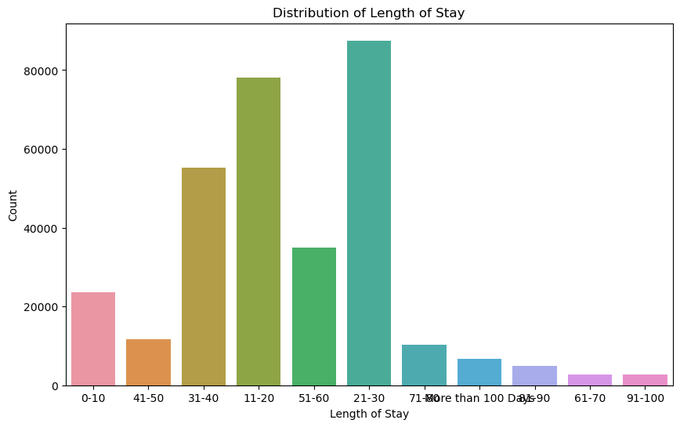

**Observation:**

From the above count plot, we can easily see that

* Most patients stay for 0-10 days, 11-20 days, or 21-30 days, making up a significant portion of the dataset.
* Longer stays (41-50 days, 51-60 days, etc.) have progressively fewer patients. Stays exceeding 100 days are the least common.

**2.Distribution of Hospital type code**

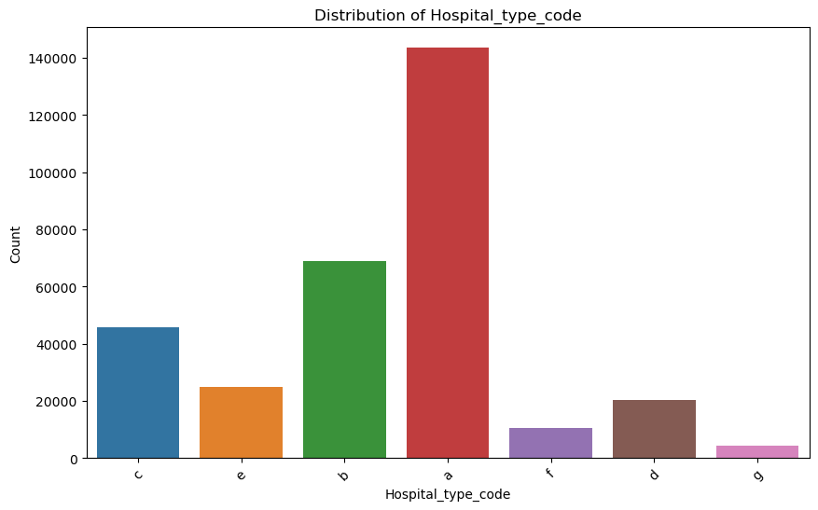

**Observation:**

From the above graph, we can see that

* Hospital type 'a' consistently has the highest patient count across most length-of-stay categories, indicating it may be larger or serve more patients with longer stays
* Different hospital types show significant variability in patient counts, especially for longer stay categories.
* This suggests specialization in specific conditions or better resources for managing longer-stay patients.

**3.Distribution of Department**

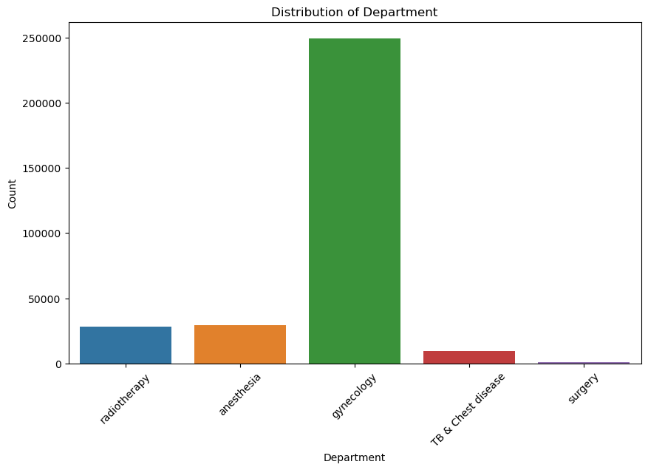

**Observation:**

From the above graph, we can see that

* Gynecology has the highest patient count, possibly indicating a high volume of cases or longer stays.
* Surgery and TB & Chest Disease have fewer patients, suggesting smaller caseloads or shorter stays on average.

**4.Distribution of Hospital type code**



**Observation:**

From the above graph, we can see that

* Hospital type 'a' consistently has the highest patient count across most length-of-stay categories, suggesting it may be larger or specialize in longer-stay conditions.
* Different hospital types show significant variability in patient counts, especially for longer stays, indicating specialization or better resources for managing longer stays.

**5.Distribution of Ward Type**

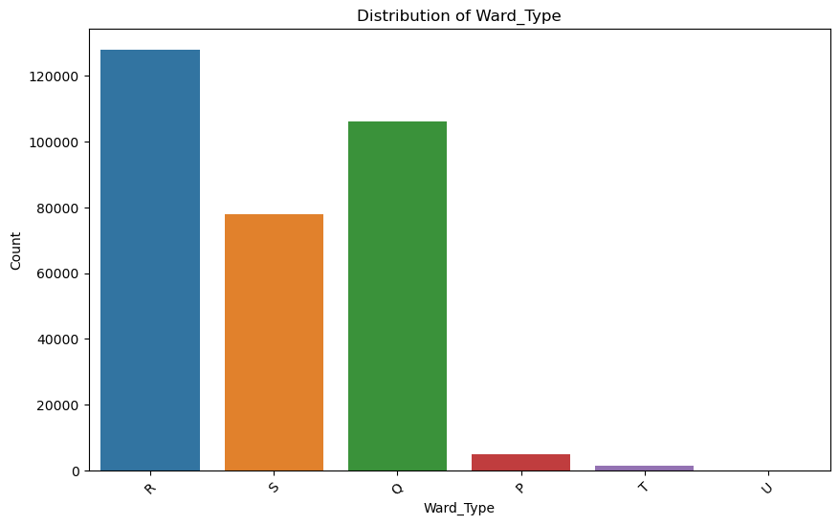

**Observation:**

From the above graph, we can see that

* The graph shows patients are admitted to various ward types, with some more common than others.
* Patients are unevenly distributed across ward types and length-of-stay categories, suggesting certain wards may specialize in different lengths of stay.

**6.Distribution of Ward Facility Code**

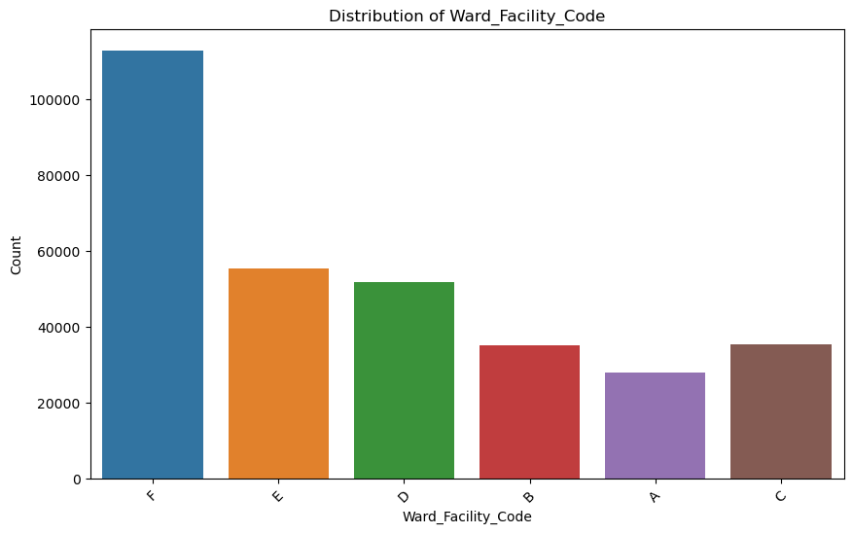

**Observation:**

From the above graph, we can see that

* Patients are admitted to various ward facilities (codes a-f), with uneven distribution across length-of-stay categories.
* The distribution of patients across ward facilities and length-of-stay categories varies. Some facilities may have more patients in specific stay categories, such as ward facility "a" for 11-20 days and "d" for 51-60 days.

**7.Distribution of Type of Admission**

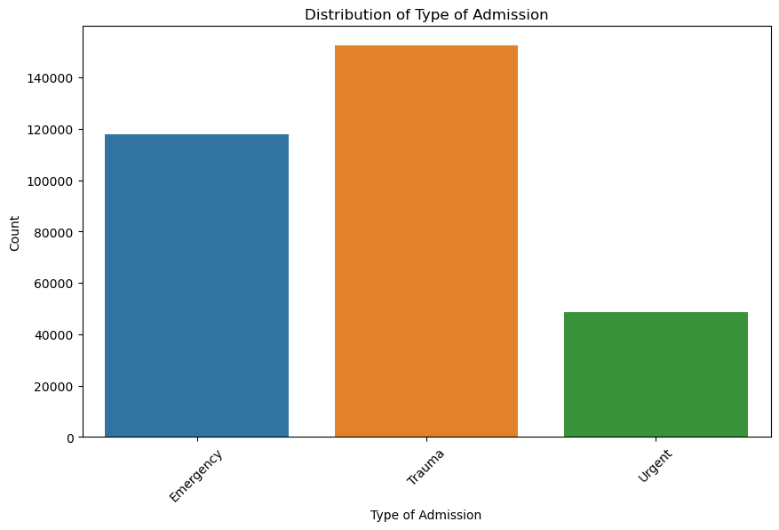

**Observation:**

From the above graph, we can see that

* Trauma admissions are most common, followed by emergency admissions and then urgent admissions, indicating the hospital's focus on handling trauma cases.
* Urgent admissions are the least common, possibly due to the hospital's location or patient demographics.

**8.Distribution of Severity of Illness**

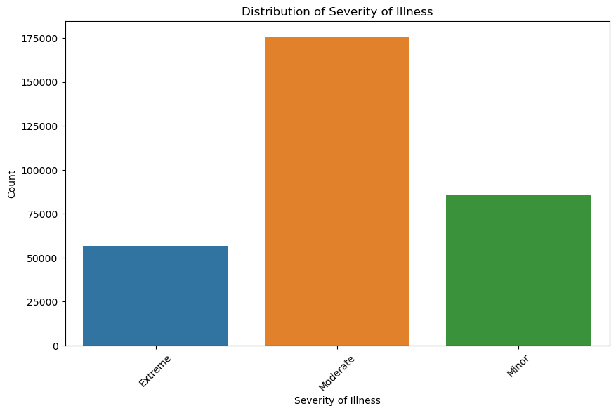

**Observation:**

From the above graph, we can see that

* There's a direct relationship between severity of illness and hospital stay length. As severity increases (from Minor to Extreme), longer stays are more common.
* Patients with moderate severity have the highest likelihood of longer stays.
* Patients with extreme severity tend to have shorter stays.

**9.Distribution of Age**

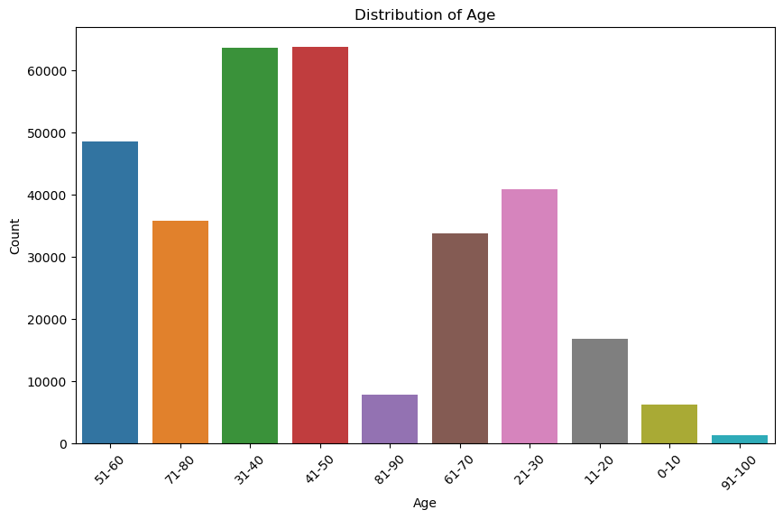

**Observation:**

From the above graph, we can see that

1. The graph shows variations in length of stay across age groups, with older adults (61-100) more likely to have longer stays.

2. Younger age groups (0-30) mostly have shorter stays, but there's some variability.

3. This age range shows a mixed distribution, suggesting factors other than age might play a role in length of stay.

**The transactions all are form the linear regression model**

**Transaction 1**

"Results": {

"WebServiceOutput0": [

{

"case_id": 1,

"Hospital_code": 8,

"Hospital_type_code": "c",

"City_Code_Hospital": 3,

"Hospital_region_code": "Z",

"Available Extra Rooms in Hospital": 3,

"Department": "radiotherapy",

"Ward_Type": "R",

"Ward_Facility_Code": "F",

"Bed Grade": 2,

"patientid": 31397,

"City_Code_Patient": 2,

"Type of Admission": "Emergency",

"Severity of Illness": "Extreme",

"Visitors with Patient": 2,

"Age": "51-60",

"Admission_Deposit": 2,

"Stay": "0-10",

"Scored Labels": 1.7731122080069408

},

**Observation**

* From the above transaction 1 we can say that:  
  The "Scored Labels" value of approximately 1.77 suggests a prediction for a relatively short stay (0-10 days) for the patient in case 1.
* Predicting a short stay can help hospitals allocate resources more efficiently, as shorter stays typically require fewer resources compared to longer stays.
* It can also help in managing patient expectations and planning for post-discharge care.

**Transaction 2**

{

"case_id": 2,

"Hospital_code": 2,

"Hospital_type_code": "c",

"City_Code_Hospital": 5,

"Hospital_region_code": "Z",

"Available Extra Rooms in Hospital": 2,

"Department": "radiotherapy",

"Ward_Type": "S",

"Ward_Facility_Code": "F",

"Bed Grade": 2,

"patientid": 31397,

"City_Code_Patient": 2,

"Type of Admission": "Trauma",

"Severity of Illness": "Extreme",

"Visitors with Patient": 2,

"Age": "51-60",

"Admission_Deposit": 2,

"Stay": "41-50",

"Scored Labels": 3.1333467696597617

},

**Observation**

* From the above transaction 2 we can say that  
  The patient's extreme severity of illness, advanced age, and admission due to trauma suggest a complex medical condition requiring specialized care and a potentially lengthy hospital stay.
* The patient's stay in the radiotherapy department may indicate a need for ongoing treatment, such as radiotherapy sessions, which can extend the length of stay.
* The predicted length of stay of 41-50 days suggests that the patient's condition and treatment plan may involve a prolonged recovery period and ongoing care**.**

**Transaction 3**

{

"case_id": 3,

"Hospital_code": 10,

"Hospital_type_code": "e",

"City_Code_Hospital": 1,

"Hospital_region_code": "X",

"Available Extra Rooms in Hospital": 2,

"Department": "anesthesia",

"Ward_Type": "S",

"Ward_Facility_Code": "E",

"Bed Grade": 2,

"patientid": 31397,

"City_Code_Patient": 2,

"Type of Admission": "Trauma",

"Severity of Illness": "Extreme",

"Visitors with Patient": 2,

"Age": "51-60",

"Admission_Deposit": 2,

"Stay": "31-40",

"Scored Labels": 2.6525972962717153

}

]

}

}

**Observation**

* Similar to case 2, the patient's extreme severity of illness, advanced age, and admission due to trauma suggest a complex medical condition requiring specialized care and a potentially lengthy hospital stay.
* The patient's stay in the anesthesia department may indicate a need for ongoing anesthesia-related treatment or care, which can extend the length of stay.
* The predicted length of stay of 31-40 days suggests that the patient's condition and treatment plan may involve a prolonged recovery period and ongoing care**.**

**Total Observation**

* Patients with extreme severity of illness, such as those in the "Extreme" category, require specialized care and tend to have longer hospital stays. This is evident in cases 1, 2, and 3.
* Patients in the 51-60 age group, as seen in all cases, may have more complex health issues, contributing to longer stays compared to younger age groups
* Patients admitted due to trauma, such as in cases 2 and 3, or critical conditions often require longer hospital stays for intensive care and treatment.
* The department and ward type can indicate the type of treatment and care required. For example, patients in the radiotherapy department, as in cases 2 and 3, may need ongoing treatment sessions, leading to extended stays.
* The presence of visitors, observed in all cases, can impact patient well-being and support during their hospital stay, potentially affecting the length of stay.
* The bed grade and availability of extra rooms, though not explicitly mentioned in all cases, can affect the comfort and care of patients, potentially influencing the length of stay.
* The "Scored Labels" provide predictions for the length of stay, which can help hospitals plan resources and manage patient care more effectively based on the predicted LOS range.